Project Reflection

CMST 386 Principles of Web Design and Technologies II

Richard Cao

October 2021

It was fun making websites for the class. One issue that I was having was trying to link the CSS file to the HTML file. I had difficulty connecting them in separate folders. I solved this problem by organizing my folders and wrote specific locations when linking it in the html pages. I also had issues choosing the right background color. Appearance is crucial when it comes to making websites so I was picky on what color the web pages should be. I solved this problem by looking review on what the most appealing colors were, so I that’s why I chose green. One more issue that I had trouble was choosing the right pictures. There were hundred of different pictures to choose and I wasn’t sure what to choose. Fortunately, my neighbor had helped give me suggestions. After I was done making the webpages, I feel proud about what I have accomplished.

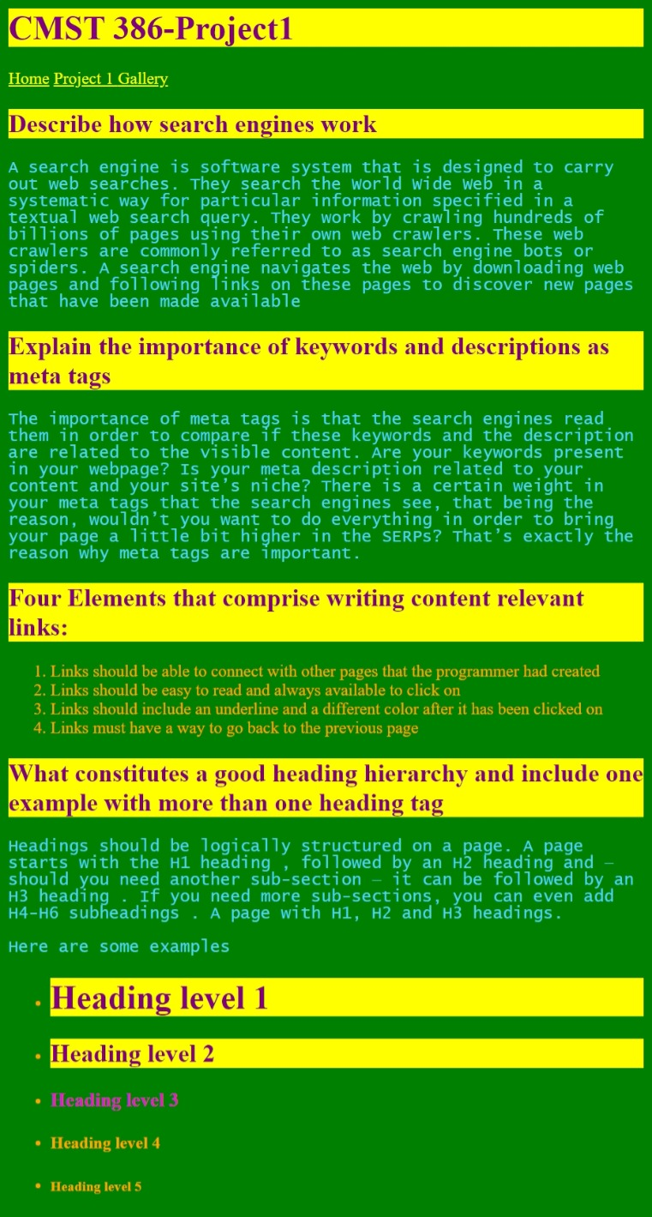 Project 1

<file:///D:/cmst386/Project%201/Project1.html>

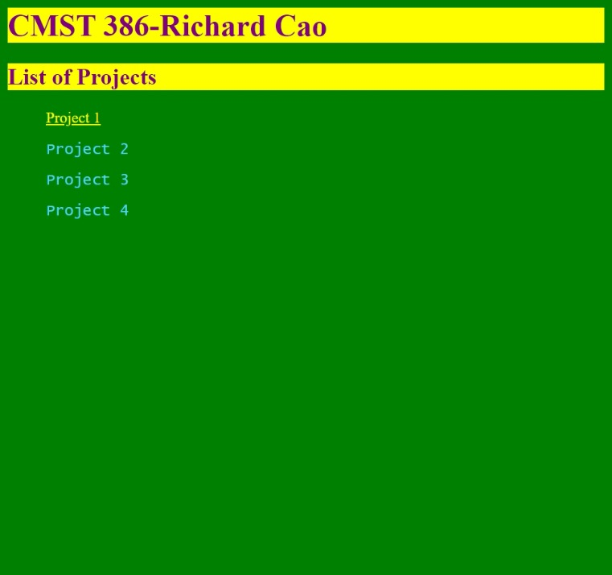

Index

<file:///D:/cmst386/Project%201/index.html>

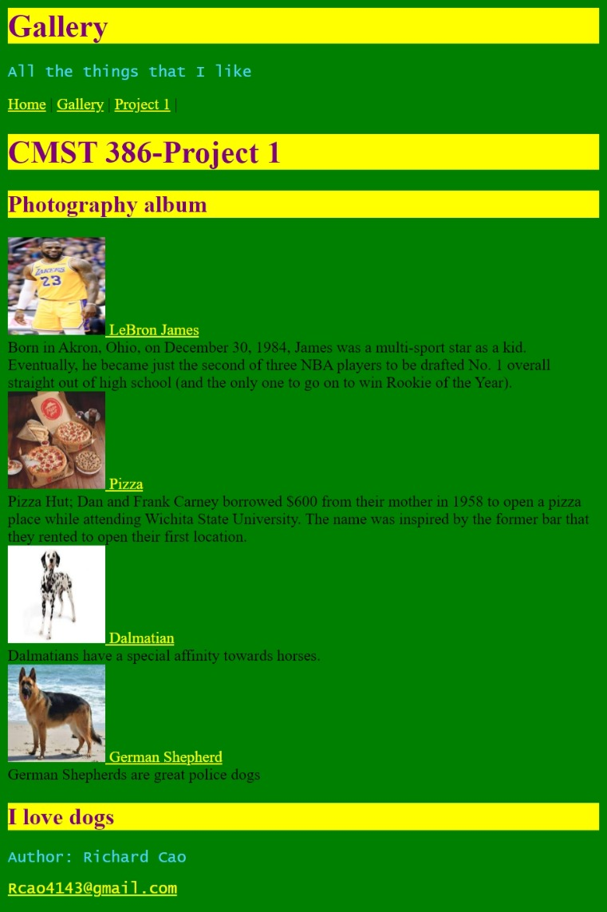 Gallery

<file:///D:/cmst386/Project%201/gallery.html>